

2018

ReoLab 8 Channel Chip and Magnet Mover Prototype

User Manual

Phease Three Product Development

Contents

Serial Command Hierarchy 2

Dino-Lite Edge 5MP Installation and Instructions 2

USB-1024LS Installation and Instructions 3

V6 MCH 8 Channel Syringe Pump Installation and Instructions 3

Notes about the IMI 8 Channel Syringe Pump 4

# Serial Command Hierarchy

The figure below is an overall hierarchy of all the serial commands for the 8 channel chip and magnet mover prototype.

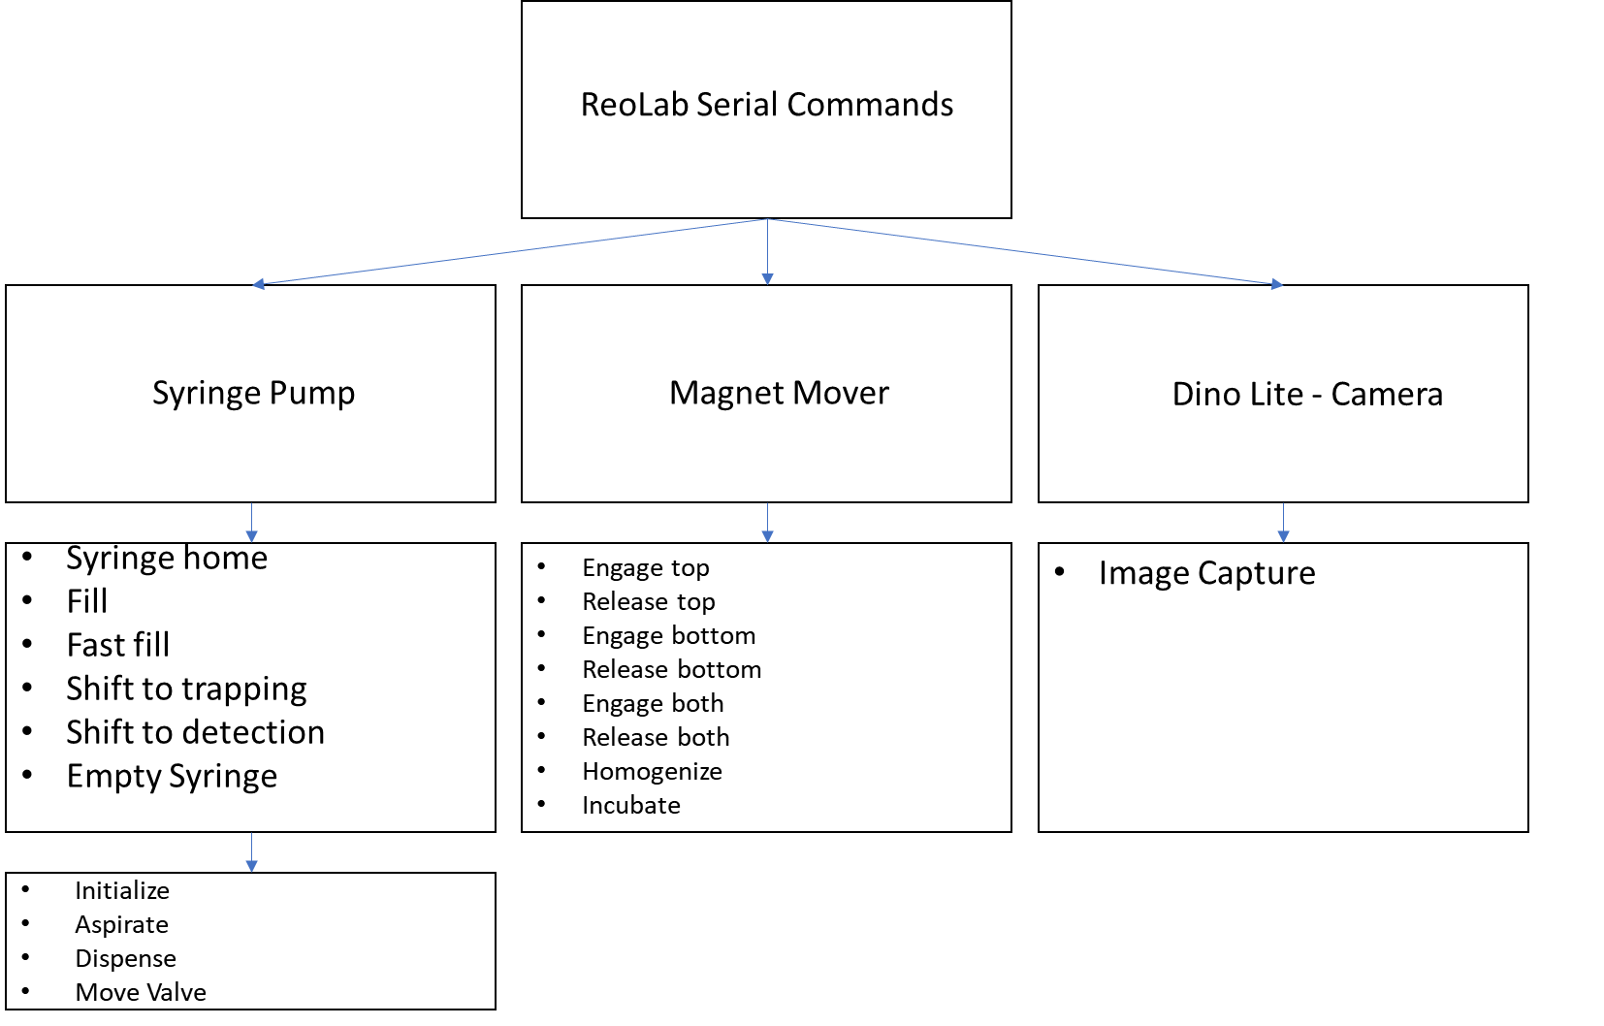

Figure 1: Hierarchy of ReoLab Serial Commands

# Dino-Lite Edge 5MP Installation and Instructions

To install the Dino-Lite Edge 5 mp camera onto a new computer, the following steps should be followed:

1. Download the Dino-lite software and drivers from the Dino-lite website (<https://www.dino-lite.com/download.php>)

*Note: Dino-lite will not work unless you download the drivers first

1. Plug in the USB of the Dino-lite to the computer
2. Open and Install the “ReoLabImageCapture” Application
3. Position the Dino-Lite to desired viewing window

# USB-1024LS Installation and Instructions

To install the magnet mover onto a new computer, the following steps should be followed:

1. Download the InstaCal software from the measurement computing website (<https://www.mccdaq.com/daq-software/instacal.aspx>)
2. Install InstaCal
   1. Update the registry
   2. Install the board and confirm the board number = 0
3. Download the MCC Universal Library Python API for Windows (<https://github.com/mccdaq/mcculw>)
   1. Follow the installation instructions
4. On the “MagCommands.py” Change the path directory to the location of the Mcculw Example download file

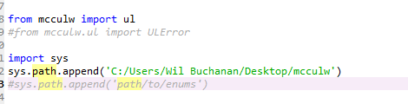

*This is required for the mcculw to function

# V6 MCH 8 Channel Syringe Pump Installation and Instructions

To install the 8 Channel syringe pump onto a new computer, the following steps should be followed:

1. Confirm the com port of the syringe pump is correct in the “ReoLab_SerialCommands.py” file
   1. Open the “ReoLab_SerialCommands.py” file
   2. Execute the “initialize_pump”
   3. If the pump initializes, the correct com is selected
   4. If this error is given, the com needs to be changed



The number on the left is the actual com port of the syringe pump. The number on the right is the com port written in the code of the “ReoLab_SerialCommands.py” file

* 1. Change the code so that the number on the left is in the code in two places:

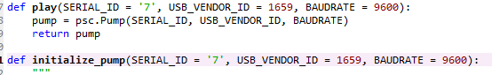

* 1. Execute the “initialize_pump” again to confirm

# Notes about the IMI 8 Channel Syringe Pump

1. Unlike the Tecan Cavro syringe pumps, the IMI pump commands do not allow you to input a type of syringe volume ie tell the pump that there is a 2.5 mL syringe. Therefore, all the commands are done in steps rather than volume. We have included a conversion factor so that all the pump serial commands take input variables in microliters.
2. This pump uses solenoid valves instead of rotary valves. This means we cannot select the valve to use when the initialize pump command is performed. When the initialize command is performed, It will always dispense anything in the syringe into the normally open valve path.
3. The absolute slowest speed the syringe pump can operate is at 5 steps/second which converts to 15 uL/min. I will also include the spreadsheet for your reference.

